**Smart Farmer-IOT Enabled Smart Farming Application**

**Project Development Phase**

**Sprint Delivery -2**

|  |  |
| --- | --- |
| **Date** | 14 November 2022 |
| **Team ID** | PNT2022TMID31434 |
| **Project Name** | Smart Farmer-IOT Enabled Smart Farming Application |
| **Leader Name** | Geetha mai A G |
| **Team Members Name** | KISHORE RAJA K  KISHORE S  DIVYA DHARSHNI A  KESAVAN P |

**Software:**

1. **Create device in the iot watson platform:**

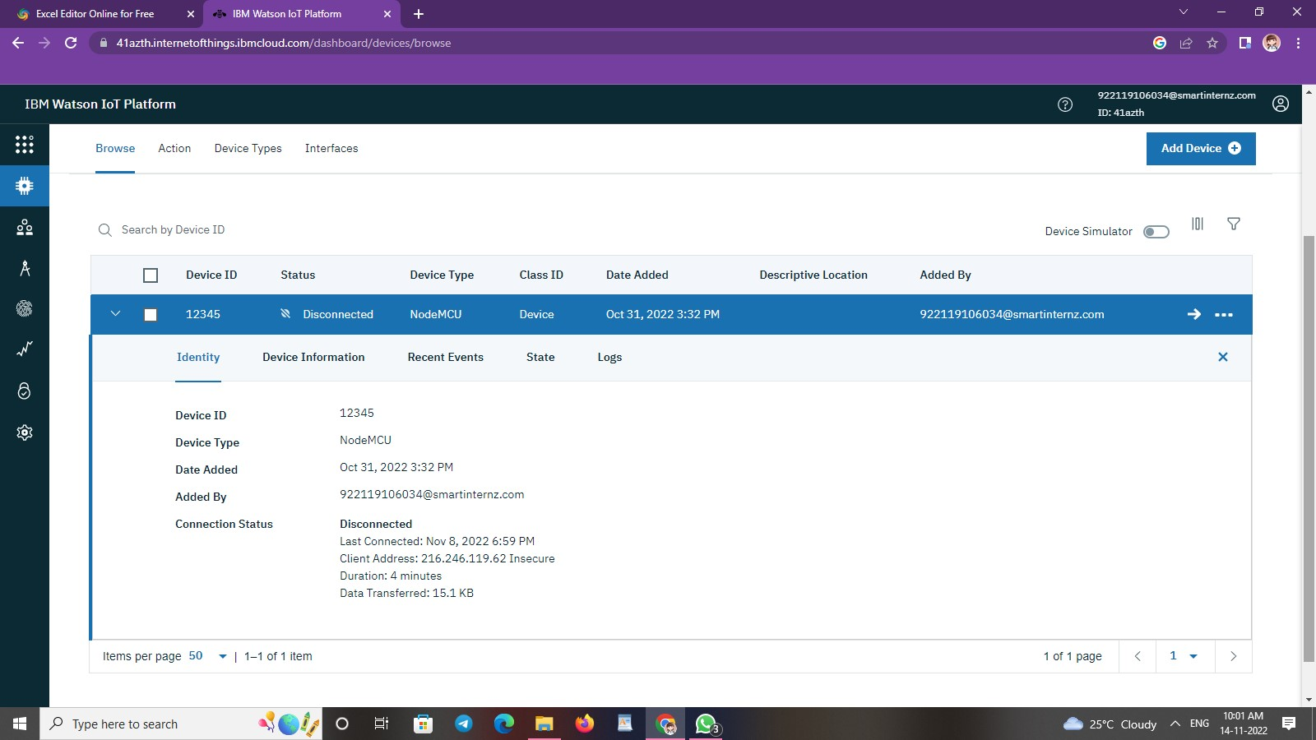

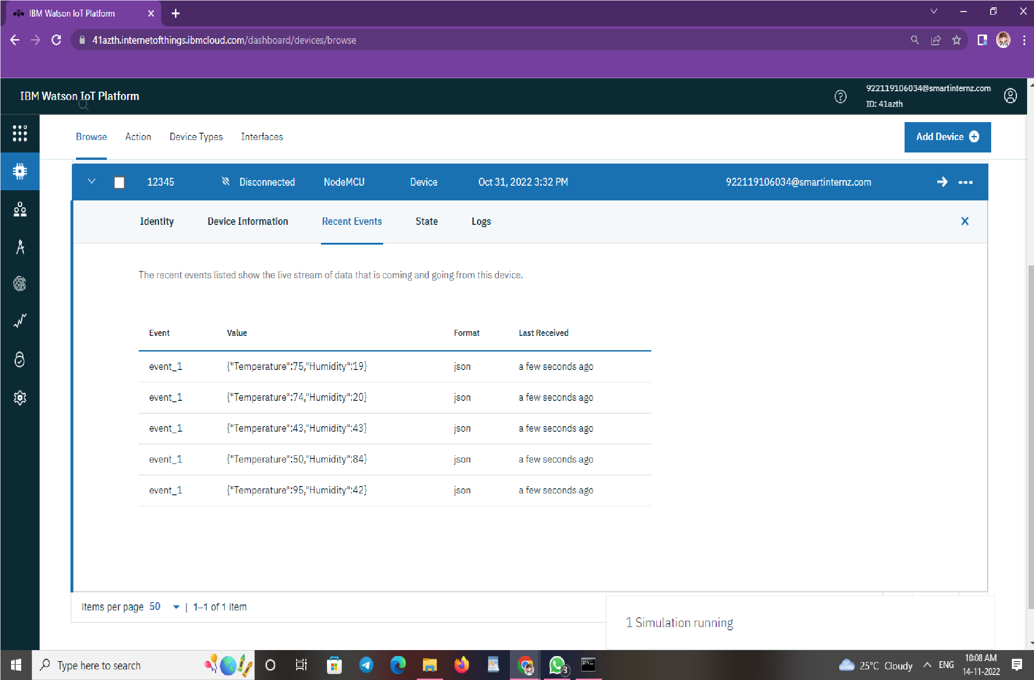

1. **Workflow for iot scenarios using local node red:**

